ARC 6098

Concur Cloudsnap Integration

ARC 6098 is an integration with Concur utilizing Cloudsnap to transfer files back and forth. It will export Vendors, POs, and Accruals to Concur, and will import Accrual Batches from Concur to GSS. The import will run off Online Update and the export will run nightly off of the task scheduler.

# Maintenance

Business Intelligence > Administration > Concur Cloudsnap Integration Maintenance [6098]

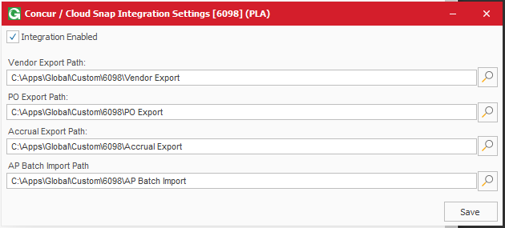

This menu is for setting up the options for this integration. To enable / disable the entire integration, use the Integration Enabled checkbox. Set the various paths for the exports and imports using the text boxes and folder browsers, and save when done.

# Import

The import can be run manually using Business Intelligence > Administration > Concur Cloudsnap Integration Manual Import [6098]. It will use the path set in the maintenance menu and process all files. The file format expected is:



# Export

The export can be run manually from Business Intelligence > Administration > Concur Cloudsnap Integration Manual Export [6098]. It will generate exports for vendors, POs, and accruals at the paths set up in the maintenance menu.

## Accrual Export:

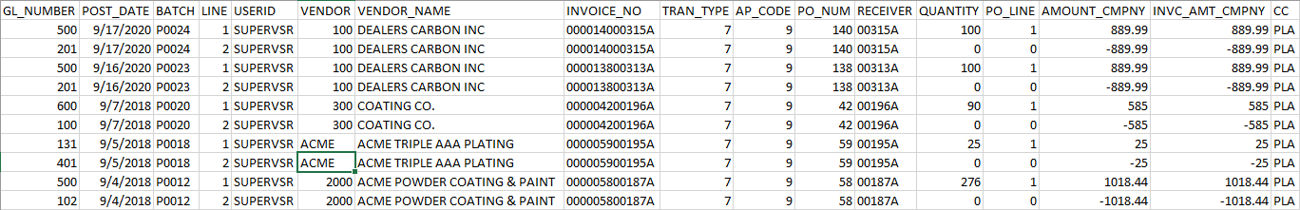

## Vendor Export:

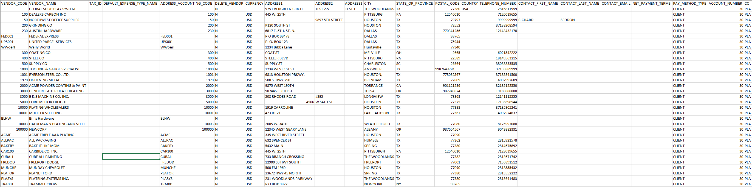

## PO Export:

